このテキストボックスに写真を挿入ください

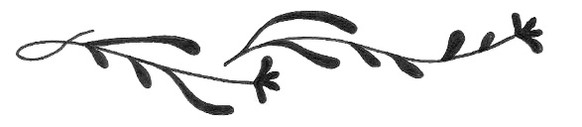

このテキストボックスに写真を挿入ください

**THE BEST DAY EVER**

このテキストボックスに写真を挿入ください

06 / 15

このテキストボックスに写真を挿入ください

Love is patient. Love is kind. It does not envy.　It does not boast, it is not proud. It is not rude, it is not self-seeking, it is not easily angered. It keeps no record of wrongs. Love does not delight in evil but rejoices with the truth. It always protects, always trusts, always hopes, always perseveres. Love never ends.





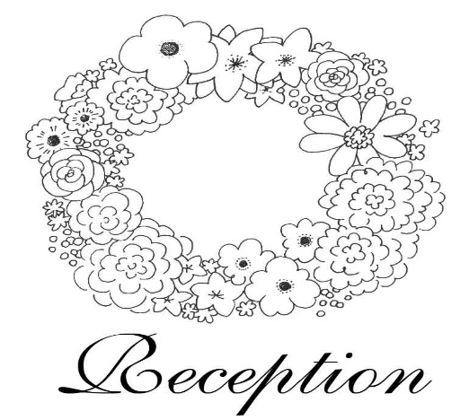

THE WEDDING TIMES

202X,JUNE,15th

このテキストボックスに写真を挿入ください

NAME & NAME ARE GETTING

MARRIED TODAY