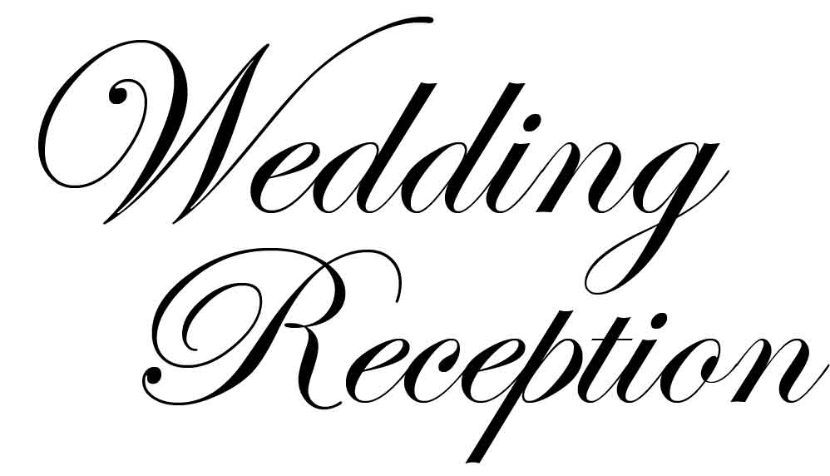

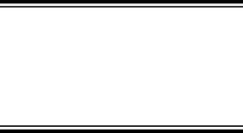

SEPTEMBER

18

2020

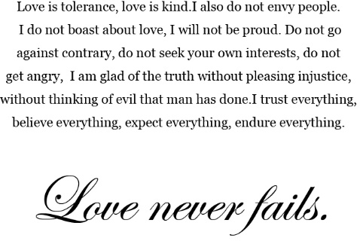

The Best Day Ever !

&

NAME〇〇〇〇

NAME〇〇〇〇